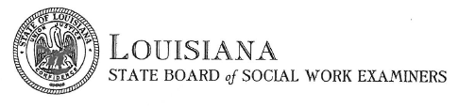
PUBLIC RECORDS REQUEST

Please complete this form to request records from the Louisiana State Board of Social Work Examiners. Please complete the information below and send to Kelly Sicard by email Kelly.sicard@labswe.org, by mail 18550 Highland Rd, Baton Rouge, LA 70809, or by fax at 225-756-3472.

Requestor’s Name
License Number
Address
Contact Number
Fax Number
Email Address

Records Requested

Payments can be made via credit card, debit card, or money order. Fee is $5.00 for the first 20 pages, then $0.25 per page after (plus postage if mailed). There is a $3.00 processing fee for credit/debit cards. Payment is required prior to your request being processed. You will be notified if your request cannot be processed within 3 business days.

Payment Information
Name on Card
Card Type (visa, mastercard, discover)
Card Number
Expiration Date
3-digit Security Code
Zip Code associated with card

OFFICE USE ONLY

