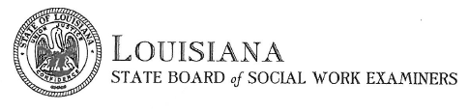
Verification Request Form
This form is used to request verification of your license, certification, or registration from the Louisiana State Board of Social Work Examiners. Please note that some jurisdictions require a specific form to be completed as part of their application process. Please complete the form and send to Kelly Sicard, by email at kelly.sicard@labswe.org, by mail, or by fax at 225-756-3472. Processing time is between 10 – 15 business days.
REQUESTOR’S NAME
LICENSE NUMBER
ADDRESS
ADDRESS 2
CITY, STATE, ZIP
PHONE NUMBER
EMAIL ADDRESS

Provide remittal instructions here

Fee is $5.00 if made by money order or cashier’s check, there is an additional $3.00 processing fee for credit card

Payment information
Name on card
Card Type (visa, mastercard, discover)
Card Number
Expiration Date
ZIP Code associated with card

OFFICE USE ONLY

