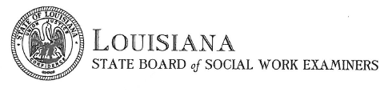
MAILING LIST REQUEST
Please complete the mailing list form, including payment information, and return to Kelly Sicard by email at Kelly.sicard@labswe.org, by mail, or by fax at 225-756-3472. The list will only include names and addresses. A disclaimer will be emailed to you once the completed form is received. The disclaimer will include both the price of your requested list and the number of licenses the price covers. Once the completed disclaimer is returned via email, mail, or fax, the list will be emailed to you as an excel spreadsheet. This list is for a one-time usage only. Processing time is between 3 – 5 business days.
Requestor’s Name
Company Name
Address
City, State, Zip
Contact Number
Fax Number
Email Address

License Type Requested (Active licenses only)
__ All categories
__ LCSW-BACS
__ LCSW
__ LMSW
__ CSW
__ RSW

Zip Codes Requested
__ All zip codes
__ Louisiana zip codes only
__ Specific zip code area(s) __________________________

Payment is $0.05 per licensee and may be made by credit card, money order, or cashier’s check. There is an additional $3.00 processing fee for credit card
Name on Card
Card Type (visa, mastercard, discover)
Card Number
Expiration Date
3-digit Security Code
Zip Code associated with card

OFFICE USE ONLY

