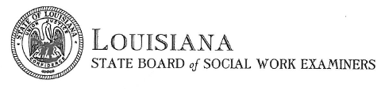

Certificate Request Form
This form is used to request a replacement license certificate (RSW, CSW, LCSW) if the original was lost, damaged, or destroyed. This form should also be used to request duplicate certificates.

REQUESTOR’S NAME
LICENSE NUMBER
ADDRESS
ADDRESS 2
CITY, STATE, ZIP
PHONE NUMBER
EMAIL ADDRESS

INSTRUCTIONS FOR NAME ON CERTIFICATE

Fee for another certificate is $25.00 if paid by money order or cashier’s check, with an additional $3.00 processing fee for cards.

Name on card
Card Type (visa, mastercard, discover)
Card Number
Expiration Date
ZIP Code associated with card

OFFICE USE ONLY

